WALL-FOLLOWING ROBOT NAVIGATION
USING MACHINE LEARNING
Final-Term Project Report
Course: Programming in Python
Semester: Summer 25-26
Group Members
[ANIKA SULTANA ANU] - [23-51807-2]
[MOST. FATEMATUZ JOHORA CHADNI] - [23-51812-2]
[JANNAT JARIN] - [23-51827-2]
[NUSRAT JAHAN SUMAIYA] - [23-51831-2]
12 September 2026

Summary
This project uses ultrasonic distance sensor readings to examine multiclass categorization of mobile robot navigation activities. The UCI Wall-Following Robot Navigation Data includes 4 navigation classes, 24 numerical ultrasonic sensor features, and 5,456 sequential observations. The project's leakage-aware workflow includes data provenance and audit, an ordered 60/20/20 train-validation-test split, a majority-class baseline, three candidate machine-learning models, validation-based parameter selection, final evaluation on the unaltered test set, error analysis, and reproducibility documentation.
The majority baseline had a Macro F1 of 0.156 and a validation accuracy of 45.19%. K-Nearest Neighbors (KNN) increased to 0.809 Macro F1 and 83.13% accuracy. Random Forest obtained the best validation Macro F1 of 0.985 with 99.45% validation accuracy, while Decision Tree obtained 99.08% accuracy and 0.976 Macro F1. Thus, Random Forest was chosen prior to the examination of the test set. The final Random Forest obtained 0.984 Macro F1 and 98.53% test accuracy after retraining on the total development data, with 16 mistakes out of 1,092 test observations.

The results demonstrate strong predictive structure in the recorded sensor data, they should not be treated as proof of safe, general-purpose autonomous navigation. The dataset comes from one SCITOS G5 robot, one room, clockwise wall-following, and four recorded rounds; adjacent observations are also sequentially correlated. Further evaluation across robots, environments, obstacles, sensor failures, and independently collected runs is required before deployment.

2. Problem Statement, Stakeholders, Objective, and Success Criteria

2.1 Problem Statement
A mobile robot operating near walls and obstacles must choose an appropriate movement action from the spatial information available to its sensors. In this project, each observation represents one sequential robot state described by 24 ultrasonic sensor readings. The prediction target is one of four actions: Move-Forward, Slight-Right-Turn, Sharp-Right-Turn, or Slight-Left-Turn.
The central project question is: Which machine-learning model best predicts a mobile robot's navigation action from its ultrasonic distance-sensor readings?

2.2 Stakeholders

Researchers and engineers working on sensor-based mobile robot navigation are the main stakeholders. They can determine which standard classification method offers the most convincing performance on this dataset and whether the current sensor readings contain enough information to differentiate the recorded navigation activities with the aid of a trustworthy classifier.

2.3 Objective and Success Criteria
The objective is to build a reproducible multiclass classification workflow that predicts the robot's navigation action using all 24 ultrasonic readings while protecting the final test set from model-development decisions.
- The candidate models should perform substantially better than a majority-class baseline.
- Performance should be evaluated across all four classes rather than by overall Accuracy alone.
- Macro Precision, Macro Recall, Macro F1, class-wise Precision/Recall/F1, and confusion matrices should support the conclusion.
- Model and hyperparameter selection must use training and validation evidence only; the final test set must remain untouched until final evaluation.
- The final recommendation must be supported by predictive performance, error analysis, computational evidence, and practical limitations.

3. Dataset Source, License, Data Dictionary, Privacy, and Ethics

3.1 Source and Collection Context
The project uses the 24-sensor version of the UCI Wall-Following Robot Navigation Data. According to the UCI Machine Learning Repository, the SCITOS G5 robot followed the wall of a room clockwise for four rounds while 24 ultrasound sensors arranged around the robot recorded measurements at approximately 9 samples per second [1]. The selected file contains 5,456 observations, 24 real-valued sensor attributes, and one class label.
Dataset Property | Value
Dataset | Wall-Following Robot Navigation Data
Repository | UCI Machine Learning Repository
Dataset ID | 194
DOI | 10.24432/C57C8W
License | CC BY 4.0
Task | Multiclass classification
Instances | 5,456
Features | 24 numerical ultrasonic sensor readings
Target | Class (4 navigation actions)
Missing values | None reported by UCI; none found in the project audit
Table 1. Dataset summary

3.2 Data Dictionary
All US1-US24 variables are numerical ultrasonic sensor readings. UCI does not specify a measurement unit for these variables. The project also submits a separate data/data_dictionary.md file. The compact dictionary below lists every sensor and its reference angle.
Sensor | Angle | Sensor | Angle | Sensor | Angle | Sensor | Angle
US1 | 180° (front) | US2 | -165° | US3 | -150° | US4 | -135°
US5 | -120° | US6 | -105° | US7 | -90° | US8 | -75°
US9 | -60° | US10 | -45° | US11 | -30° | US12 | -15°
US13 | 0° (back) | US14 | 15° | US15 | 30° | US16 | 45°
US17 | 60° | US18 | 75° | US19 | 90° | US20 | 105°
US21 | 120° | US22 | 135° | US23 | 150° | US24 | 165°
Table 2. Compact data dictionary for the 24 ultrasonic sensors
Target variable: Class (categorical) with four labels: Move-Forward, Slight-Right-Turn, Sharp-Right-Turn, and Slight-Left-Turn.

3.3 Privacy, Permission, and Ethical Considerations
The dataset is publicly available under the Creative Commons Attribution 4.0 International (CC BY 4.0) license [1]. It contains robot sensor measurements and navigation labels rather than personal or sensitive human information, so direct personal-privacy risk is minimal.
The main ethical concern is safety rather than privacy. A wrong movement prediction could be harmful if a model were connected directly to a physical robot. The classifier is therefore treated as an experimental prediction model, not as a complete safety-critical controller. Any real deployment would require independent safety mechanisms and testing under failures and environmental changes.

4. Data Audit, Exploratory Analysis, and Visualization Findings

4.1 Data Audit
The raw file is preserved unchanged. The audit verified shape, column types, missing values, duplicate rows, class labels, sensor ranges, non-negativity, and class distribution. The working dataset contains 5,456 rows and 25 columns (24 sensor features plus the Class target).
Audit Check | Result
Missing values | 0
Duplicate rows | 0
Valid class labels | All rows valid
Non-negative sensor values | All readings non-negative
Sensor maxima | Approximately 5.0 across sensors; no justified invalid cutoff was provided
Cleaning action | No rows removed; no imputation; raw observations retained
Table 3. Data-audit summary
Extreme values were inspected using sensor minima/maxima and percentile summaries. Because the project had no documented invalid maximum threshold, relatively high or low valid readings were not removed merely for being extreme.

4.2 Target-Class Distribution
Class | Count | Percentage
Move-Forward | 2,205 | 40.41%
Sharp-Right-Turn | 2,097 | 38.43%
Slight-Right-Turn | 826 | 15.14%
Slight-Left-Turn | 328 | 6.01%
Table 4. Overall target-class distribution
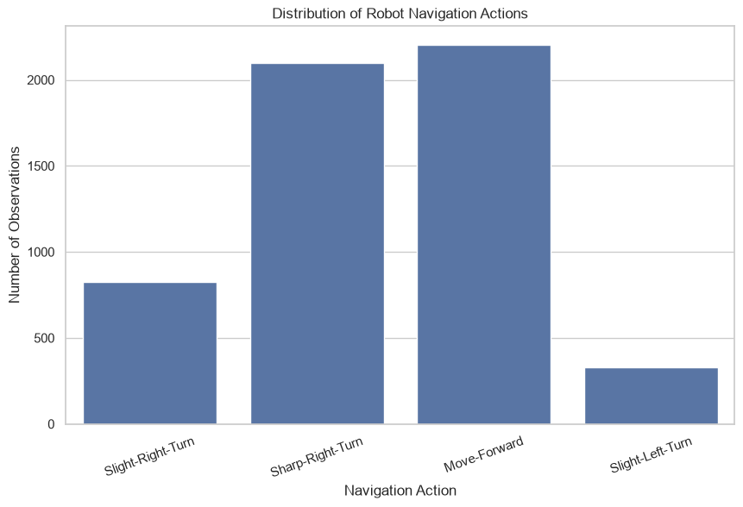
Figure 1. Target-class distribution in the complete dataset.
The class distribution is clearly imbalanced. Move-Forward and Sharp-Right-Turn account for most observations, whereas Slight-Left-Turn is much less frequent. This motivated the use of Macro F1 and class-wise metrics in addition to Accuracy.

4.3 Exploratory Relationships
Histograms were generated for representative sensors (including US1, US7, US13, and US19) to examine distributional differences around the robot. Scatterplots and a pairplot were then used to inspect relationships among front, back, and side sensor readings.
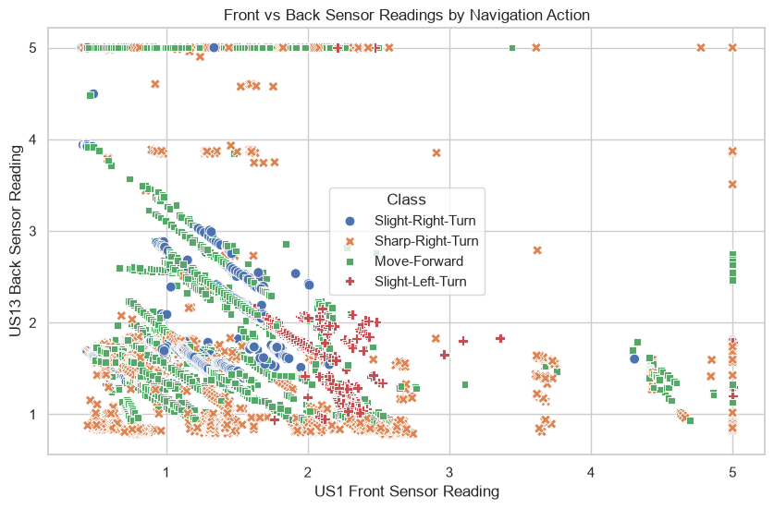
Figure 2. Relationship between the front sensor (US1) and back sensor (US13), coloured by navigation action.
The front-versus-back plot shows that the navigation classes occupy different regions in some areas but still overlap substantially. Similar overlap appears for the selected side-sensor relationship and the multi-sensor pairplot. The exploratory evidence therefore supports using multiple sensors together rather than relying on one or two individual readings.

5. Split Strategy, Preprocessing Decisions, and Leakage Controls

5.1 Ordered Train/Validation/Test Split
The UCI dataset is sequential: adjacent rows were sampled closely in time while the robot completed four rounds [1]. Because explicit round identifiers are not available in the selected 24-sensor file, the project preserves the original row order instead of randomly shuffling nearby observations.
Partition | Observations | Purpose
Training | 3,273 (60%) | Fit candidate models and training-only preprocessing
Validation | 1,091 (20%) | Select hyperparameters and compare candidate models
Test | 1,092 (20%) | One final evaluation after model selection
Table 5. Ordered data split
The split is implemented with shuffle=False. The first 80% is separated from the final 20% test block; the development portion is then divided into 60% training and 20% validation. All four classes are present in the training and validation partitions.

5.2 Preprocessing
- Missing-value imputation is not used because the audit found no missing values.
- Categorical encoding is not needed because all 24 input features are numerical; the target labels can be used directly by scikit-learn classifiers.
- KNN uses StandardScaler inside a Pipeline because distance-based predictions are sensitive to feature scale.
- The StandardScaler is fitted only on X_train and then applied consistently to validation observations through the pipeline.
- Decision Tree and Random Forest use the original numerical features because tree splits do not require feature scaling.
- All 24 sensor features are retained; no feature-selection step is fitted.

5.3 Leakage Control
The final test set is separated before model development. It is not used for scaling, hyperparameter selection, candidate-model comparison, or final-model choice. KNN scaling is fitted only on training data through a pipeline. Hyperparameters are selected using validation Macro F1. Only after the final model and its configuration are locked is the selected model retrained on the complete development set (training + validation) and evaluated on X_test.

6. Baseline Definition and Result
A majority-class baseline provides a simple reference. The most common class in the training partition is Move-Forward, so the baseline predicts Move-Forward for every validation observation.
Metric | Value | Interpretation
Validation Accuracy | 45.19% | Moderate only because Move-Forward is common
Macro Precision | 0.113 | Very low across the four classes
Macro Recall | 0.250 | Only one of four classes is ever predicted
Macro F1 | 0.156 | Poorly balanced multiclass performance
Table 6. Majority-class baseline performance on validation data
The baseline has recall 1.00 for Move-Forward but zero Precision/Recall/F1 for the other three classes. This demonstrates why Accuracy alone would be misleading for this imbalanced problem and establishes a clear reference that every candidate model should outperform.

7. Candidate Models, Model-Choice Reasoning, Hyperparameters, and Validation
The project compares three distinct classifiers implemented with scikit-learn [2]. All models use the same training and validation observations. Validation Macro F1 is the primary selection measure because it weights each class equally.

7.1 K-Nearest Neighbours (KNN)
KNN was chosen because observations with similar 24-sensor patterns may correspond to similar navigation actions. Because KNN relies on distances, StandardScaler is included in a Pipeline. Candidate odd values of k were compared on the validation set: 1, 3, 5, 7, 9, 11, and 15. The best validation Macro F1 occurred at k=3.
Selected configuration: StandardScaler -> KNeighborsClassifier(n_neighbors=3).

7.2 Decision Tree
Decision Tree was chosen because navigation actions may be separated by nonlinear threshold relationships among the sensor readings. Scaling is unnecessary. The tested max_depth values were 3, 5, 7, 10, 15, and None. Depths 7, 10, 15, and None tied on validation Macro F1; the project selected the first best result, max_depth=7, which achieves the same validation score with a more limited depth.
Selected configuration: DecisionTreeClassifier(max_depth=7, random_state=42).

7.3 Random Forest
Random Forest was chosen as a combined alternative that can model nonlinear relationships and interactions among the 24 numerical features. Using 100 trees, the project initially compared max_depth values of 5, 7, 10, 15, and None; max_depth=10 yielded the strongest validation Macro F1. After comparing the number of trees at 50, 100, 150, and 200, the first best value, 100, was chosen after 100 and 150 tied for the highest Macro F1.
Selected configuration: RandomForestClassifier(n_estimators=100, max_depth=10, random_state=42). The project leaves max_features at the scikit-learn default and does not use feature importance for feature selection.
The selected Random Forest reaches perfect training Accuracy and Macro F1 (1.000), while validation performance is slightly lower. This shows some train-validation gap, although validation performance remains very strong. Feature-importance values are not interpreted as causal evidence.
Model | Parameter(s) Examined | Values Tested | Selected
KNN | n_neighbors | 1, 3, 5, 7, 9, 11, 15 | k = 3
Decision Tree | max_depth | 3, 5, 7, 10, 15, None | 7
Random Forest | max_depth | 5, 7, 10, 15, None | 10
Random Forest | n_estimators | 50, 100, 150, 200 | 100
Table 7. Hyperparameter-selection summary

8. Final Metrics, Diagnostic Plots, Model Comparison, and Computational Cost

8.1 Validation Comparison and Final Model Selection
Model | Accuracy | Macro Precision | Macro Recall | Macro F1
Majority Baseline | 0.4519 | 0.1130 | 0.2500 | 0.1556
KNN | 0.8313 | 0.7762 | 0.8568 | 0.8092
Decision Tree | 0.9908 | 0.9692 | 0.9827 | 0.9758
Random Forest | 0.9945 | 0.9921 | 0.9787 | 0.9850
Table 8. Validation performance of all candidate approaches
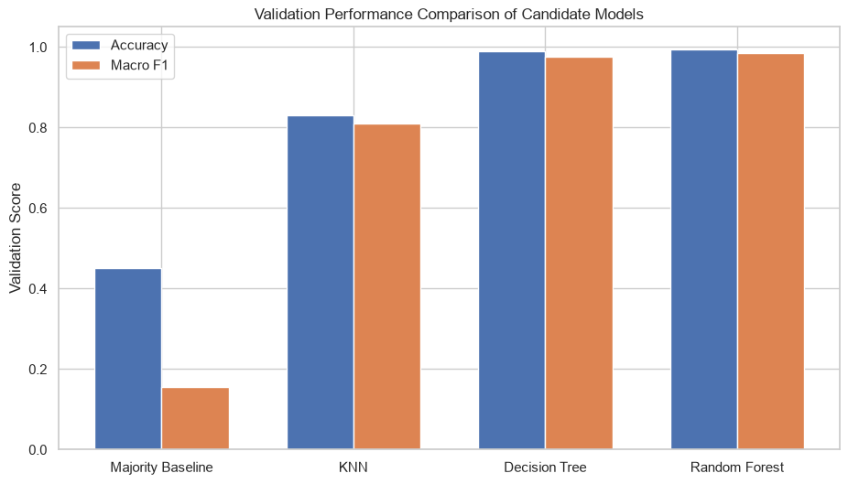
Figure 3. Validation Accuracy and Macro F1 comparison.
Random Forest has the highest validation Macro F1 (0.9850) and Accuracy (0.9945), so it is selected before any final test prediction is made. Decision Tree has slightly higher Macro Recall than Random Forest, but Random Forest has stronger Macro Precision and Macro F1. Because the metric differences between the two tree models are small, the result is interpreted as a strong but dataset-specific advantage rather than proof of universal superiority.

8.2 Computational Cost
Model | Training Time (s) | Validation Prediction Time (s)
KNN | 0.0461 | 0.0604
Decision Tree | 0.1063 | 0.00524
Random Forest | 1.5799 | 0.0348
Table 9. Approximate computational timing from one notebook run
Random Forest required the longest fitting time, while Decision Tree produced the fastest validation predictions in this run. KNN trains quickly because little model structure is learned during fit, but its neighbour search makes prediction slower than the tree models here. These timings are approximate and machine-dependent. The notebook did not record hardware specifications, so they should not be treated as portable benchmark results.

8.3 Final Test Evaluation
After Random Forest and its hyperparameters were locked, the same configuration was retrained on the complete development set (the original training and validation observations) and evaluated once on the reserved test block.
Metric | Final Test Result
Accuracy | 0.985348 (98.53%)
Macro Precision | 0.984259
Macro Recall | 0.983661
Macro F1 | 0.983717
Correct predictions | 1,076 / 1,092
Incorrect predictions | 16 / 1,092
Error rate | 1.465%
Table 10. Final Random Forest test performance
Class | Precision | Recall | F1 | Support
Move-Forward | 0.9952 | 0.9720 | 0.9835 | 429
Sharp-Right-Turn | 0.9808 | 1.0000 | 0.9903 | 408
Slight-Left-Turn | 1.0000 | 0.9626 | 0.9810 | 107
Slight-Right-Turn | 0.9610 | 1.0000 | 0.9801 | 148
Table 11. Final class-wise test metrics
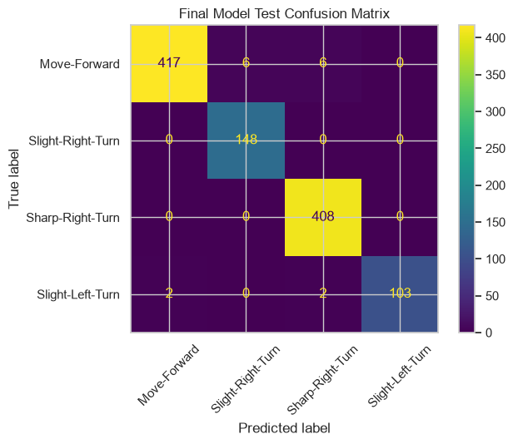
Figure 4. Final Random Forest confusion matrix on the untouched test set.

9. Error Analysis, Imbalance, Assumptions, Bias, Uncertainty, and Generalization

9.1 Error Analysis
The final model makes 16 errors among 1,092 test observations. The mistakes are concentrated in four actual-predicted pairs rather than being distributed evenly.
Actual Class | Predicted Class | Count
Move-Forward | Sharp-Right-Turn | 6
Move-Forward | Slight-Right-Turn | 6
Slight-Left-Turn | Move-Forward | 2
Slight-Left-Turn | Sharp-Right-Turn | 2
Table 12. Final test error pairs
Most errors occur when a true Move-Forward state is predicted as a right-turn action. A smaller number of Slight-Left-Turn states are confused with Move-Forward or Sharp-Right-Turn. These remaining mistakes are consistent with the EDA observation that classes overlap in some sensor configurations. In a physical controller, such errors could alter the robot's path and therefore cannot be dismissed simply because the overall error rate is low.

9.2 Class Imbalance
The full dataset contains 40.41% Move-Forward and 38.43% Sharp-Right-Turn observations, but only 6.01% Slight-Left-Turn observations. The baseline demonstrates the danger of relying on Accuracy alone: always predicting Move-Forward yields 45.19% validation accuracy but a Macro F1 of only 0.156. For this reason, the project uses Macro F1 as the primary selection metric and reports class-wise results.

9.3 Assumptions, Bias, and Uncertainty

- The dataset does not include clear round or session IDs, so a proper round-based group split cannot be performed.
- The observations are recorded at about 9 Hz, so nearby data points may still be similar even when an ordered split is used.
- The evaluation uses only one train, validation, and test split. Since repeated testing or confidence intervals are not used, the exact performance results may vary.
- The dataset was collected using one robot in one room with clockwise wall-following and limited navigation conditions. Therefore, the results may not fully represent other robots, rooms, or environments.
- The four classes are not balanced, meaning some classes have more samples than others. Macro metrics help reduce this effect, but they do not create more examples for rare classes.
- Random Forest is harder to understand than a simple decision tree. Feature-importance values only show which features the model uses more and should not be treated as proof of cause and effect.
- The runtime results are based on one run and may change depending on the computer hardware and other programs running in the background.

9.4 Generalization Limits
High performance on this dataset does not establish equivalent performance in different rooms, with different obstacle geometry, robot hardware, sensor calibration, sensor failures, or environmental noise. Distribution shift could change both class frequencies and sensor-action relationships. The final result should therefore be interpreted as evidence for this dataset and split, not as a general safety guarantee.

10. Reproducibility Information: Seeds, Versions, Run Instructions, and File Structure

10.1 Randomness and Environment
Decision Tree and Random Forest use random_state=42. The data split itself is deterministic because shuffle=False. The notebook prints the Python and package versions, and requirements.txt pins the package versions used by the project.
Software | Version
Python | 3.13.14
NumPy | 2.5.3
pandas | 3.0.5
Matplotlib | 3.11.1
Seaborn | 0.13.2
scikit-learn | 1.9.0
Jupyter | 1.1.1
Table 13. Recorded software environment

10.2 Project File Structure
robot-navigation-ml/
├── data/
│ ├── data_dictionary.md
│ └── raw/
│ └── sensor_readings_24.data
├── figures/
├── notebooks/
│ └── robot_navigation.ipynb
├── presentation/
├── report/
├── .gitignore
├── README.md
└── requirements.txt

10.3 Run Instructions
- Open the repository root in Visual Studio Code.
- Create a virtual environment with: python -m venv .venv
- Activate it in Windows PowerShell with: .\.venv\Scripts\Activate.ps1
- Install packages with: python -m pip install -r requirements.txt
- Open notebooks/robot_navigation.ipynb.
- Select the interpreter from the project's .venv\Scripts\python.exe.
- Restart the kernel and choose Run All so the notebook executes from data loading through the final result.
The notebook uses relative project paths and regenerates the principal tables, plots, validation comparisons, final metrics, and error analysis when executed in order from a clean kernel.

11. Conclusion, Practical Interpretation, Responsible Use, and Future Improvement

11.1 Conclusion
The project successfully developed an end-to-end, reproducible classification workflow for predicting wall-following robot navigation actions from 24 ultrasonic sensor readings. The majority baseline performed poorly across the four classes despite moderate Accuracy, while KNN significantly improved balanced performance. Decision Tree and Random Forest produced much stronger results, demonstrating that nonlinear tree-based decision boundaries fit the recorded sensor-action relationships well.
Random Forest was selected using validation Macro F1 before the test set was examined. Its final evaluation produced 98.53% Accuracy, 0.9843 Macro Precision, 0.9837 Macro Recall, and 0.9837 Macro F1. Only 16 of 1,092 test observations were misclassified. These results answer the project question for the available dataset: among the tested approaches, Random Forest provides the strongest validation evidence and retains very strong performance on the reserved test block.

11.2 Practical Interpretation and Responsible-Use Boundary
The result indicates that the 24 ultrasonic readings contain substantial information about the navigation action recorded in this experiment. However, the model should be used as an experimental navigation-action predictor only. It is not a complete collision-avoidance or safety system, and the test score must not be interpreted as a guarantee of safe behaviour outside the collected environment.

11.3 Future Improvement
Future research should gather information from various rooms, obstacle layouts, robots, and sensor conditions to better evaluate the system under distribution shifts. Explicit navigation-round or session identifiers should also be recorded so that grouped holdout or leave-one-round-out validation can be performed. Before considering real-world deployment, the system should be tested for robustness against sensor noise, missing sensor readings, and sensor failures. Evaluations should be repeated across multiple independent runs or groups, with variability or confidence intervals reported to provide a more reliable assessment of performance. Future studies should look into the use of temporal context while keeping a straightforward baseline for an equal comparison because the source data are sequential. In addition, hardware specifications should be recorded alongside runtime measurements if computational cost becomes an important factor for deployment.

12. References and Contribution Statement

12.1 References
[1] Freire, A., Veloso, M., & Barreto, G. (2009). Wall-Following Robot Navigation Data [Dataset]. UCI Machine Learning Repository. https://doi.org/10.24432/C57C8W
[2] Pedregosa, F., Varoquaux, G., Gramfort, A., Michel, V., Thirion, B., Grisel, O., Blondel, M., Prettenhofer, P., Weiss, R., Dubourg, V., Vanderplas, J., Passos, A., Cournapeau, D., Brucher, M., Perrot, M., & Duchesnay, E. (2011). Scikit-learn: Machine Learning in Python. Journal of Machine Learning Research, 12(85), 2825-2830.

12.2 Contribution Statement
The contribution statement below follows the actual project workflow. Replace the bracketed names and student IDs with the final group information and adjust any wording if the team's final division differed.
Member | Student ID | Primary Contribution
Jannat Jarin | 23-51827-2 | Dataset provenance, raw-data preservation, data dictionary, audit/cleaning decisions, class analysis, and exploratory visualization.
Anika Sultana Anu | 23-51807-2 | Feature/target definition, ordered train-validation-test split, leakage controls, majority baseline, KNN pipeline, k selection, and KNN validation.
MOST. Fatematuz Johora Chadni | 23-51812-2 | Decision Tree and Random Forest implementation, parameter comparison, validation metrics, confusion matrices, and tree-model interpretation.
Nusrat Jahan Sumaiya | 23-51831-2 | Complete model comparison, computational timing, final model selection, final test evaluation, error analysis, limitations, reproducibility, and README finalization.
Table 14. Group contribution statement

